NHS Health Checks Programme
General Practice Locally Enhanced Service Specification 2026

1. BACKGROUND AND RATIONALE
This Public Health Locally Enhanced Service (LES) Specification describes the provision of the NHS Health Check (NHS HC) programme by General Practice surgeries located within the boundary of Plymouth City Council (PCC).
This programme aims to reduce preventable morbidity and mortality through early identification and management of key modifiable cardiovascular risk factors and early detection of disease.
This NHS HC programme is a fundamental part of the local preventative public health system to reduce the impact of these risk factors, reduce the burden of early deaths and illness from leading diseases, achieve a considerable health gain across the population and relieve the pressure on the NHS.
The service described in this specification fulfils the following legal duties set out in the Local Authorities (Public Health Functions and Entry to Premises by Local Healthwatch Representatives) Regulations 2013:
- For each eligible individual to be offered an NHS HC once every five years.
- To continuously improve the percentage of eligible individuals having an NHS HC.
- For the risk assessment to include specific tests and measurements.
- To ensure the individual having their NHS HC is told their results.
- For specific information and data to be recorded and, where the risk assessment is conducted outside the individual’s GP practice, for that information to be forwarded to the individual’s GP.

2. AIMS AND OBJECTIVES OF THE SERVICE
The NHS HC programme aims to reduce preventable morbidity and mortality. The programme has three outcomes:
- Identification of people with previously unidentified established disease.
- Reduction of CV risk and prevention of future CVD.
- Increased awareness of CV risk and motivation to make effective lifestyle changes.
The programme will deliver the following public health outcome indicators:
- Cumulative % of the eligible population aged 40-74 offered an NHS HC.
- Cumulative % of the eligible population aged 40-74 offered an NHS HC who received an NHS HC.
- Cumulative % of the eligible population aged 40-74 who received an NHS HC.
The service will also contribute towards reducing premature mortality (NHS Outcomes Framework).
Ensuring a high percentage of the eligible population have the check is key to optimising the clinical and cost effectiveness of the programme. This is especially important for populations with the greatest health needs and will impact on the programme’s and local area’s ability to narrow health inequalities.
The NHS Health Check framework ensures that there is uniformity and scale of provision across England while also providing the flexibility to enable local decisions on factors including where the checks are delivered; for example, the settings that might be used, the geographic locations for provision and how best to use the programme to tackle health inequality.

3. SERVICE DESCRIPTION/PATHWAY
3.1 Service description
This programme will provide eligible patients with an individual risk assessment, indication of their cardiovascular risk, tailored provision of information and referral for additional testing and follow up, as necessary.
The NHS HC pathway consists of the provision of the following standards:
1. INVITATION AND OFFER: identifying the eligible population and offering an NHS HC
2. INVITATION AND OFFER: consistent approach to non-responders and DNAs
3. THE RISK ASSESSMENT: ensuring a complete NHS HC is undertaken and recorded
4. THE RISK ASSESSMENT: equipment
5. THE RISK ASSESSMENT: quality control for point of care testing
6. COMMUNICATION OF RESULTS: ensuring results are communicated effectively and recorded
7. RISK MANAGEMENT: high quality and timely lifestyle advice given to all
8. RISK MANAGEMENT: additional testing and clinical follow up
9. RISK MANAGEMENT: appropriate follow up for those with high CVD risk
10. THROUGHOUT THE PATHWAY: confidential and timely transfer of patient identifiable data.
Each of these standards should be delivered according to the current edition of “NHS Health Check programme standards: a framework for quality improvement” published by Office for Health Improvement and Disparities (OHID), located within the Department of Health and Social Care.
Figure 1. NHS Health Check pathway
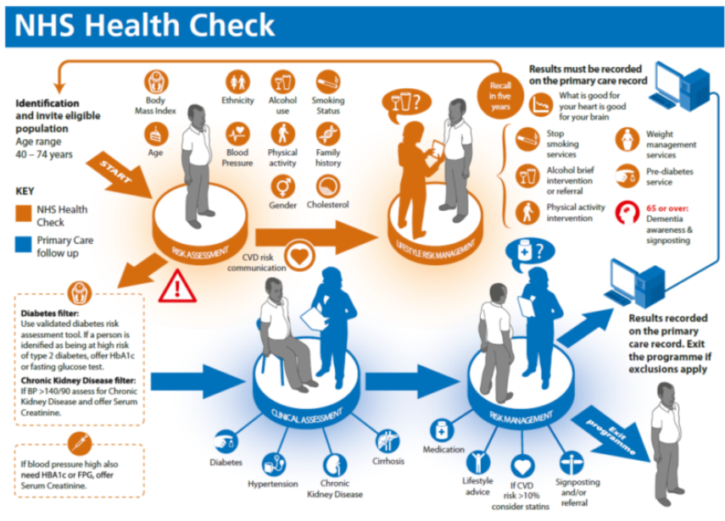
Source: Public Health England www.healthcheck.nhs.uk/commissioners_and_providers/guidance/

3.2 Eligible population
The specification applies to GP surgeries located within Plymouth City Council Boundary. The specification covers residents in Plymouth City Council Local Authority Area.

3.3 Referral pathways
Where appropriate, inter-practice referral arrangements can be made to deliver this specification. These arrangements should cover the sending of invitations, establishing eligibility and the timely provision of a completed NHS Health Check NHS Health Check Monitoring Form (see Appendix 2) to the patient’s GP.
Referral can be made either by self-referral, written invitation (see Standard 1 above) or as recommended by a member of the surgery clinical team.

3.4 Inclusion, exclusion and prioritisation criteria
The inclusion criteria for this service are:
- Patients who are registered with a GP practice located within PCC boundary, and
- Aged between 40 - 74 years, and
- Not excluded by any criteria listed in section 3.3.
People who are identified on the practice patient record with any of the following conditions, are excluded from the NHS HC programme:
- Coronary heart disease, chronic kidney disease (CKD) (classified as stage 3, 4 or 5 within NICE CG 182), diabetes, hypertension, atrial fibrillation, transient ischaemic attack, familial hypercholesterolaemia heart failure, peripheral arterial disease, stroke.
The following people are also excluded:
- People who are being prescribed statins for the purpose of lowering cholesterol.
- People who have previously received an NHS HC, or any other check undertaken through the health service in England, and found to have a 20% or higher risk of developing cardiovascular disease over the next ten years.
- People who have received an NHS HC within the previous 5 years.

3.5 Location and times of service
The service will be delivered at any location identified by the provider that meets appropriate clinical governance standards required to deliver the specification.
Core delivery hours are expected to be aligned with the provider’s normal service delivery hours.

3.6 Exiting the service
Wherever possible the provider will work to facilitate a planned exit from the service. Where appropriate and necessary the provider will ensure referral onto other services.

3.7 Interdependencies
Providers should be aware of the importance of effective partnership and system to improve the quality of care offered to residents.
Interdependencies include:
- Other GP practices, Secondary Care Services, Pathology Services, Pharmacies, Health Improvement Services, Alcohol Treatment Services, Dementia Services, services provided by Plymouth City Council.

4. SERVICE STANDARDS AND REQUIREMENTS
The providers should identify a named person to oversee the delivery of the specification and maintain an awareness of current relevant clinical guidance and its application.

4.1 Applicable local and/or national standards
Providers must ensure that provision of this specification meets the following standards of service quality and clinical governance:
- Current NHS Health Check Best Practice Guidance
- Standards for Better Health
- NHS Health Check competence framework
- Relevant guidance issued by the National Institute for Health and Care Excellence.
The practice should also:
- Identify a named person to oversee the programme and maintain an awareness and application of all current guidance.

  - Monitoring and audit
All criteria included in the template NHS HC record sheet (Appendix 2) should be recorded and coded on the individual patient’s practice record.
Data extraction may be undertaken by the NEW Devon CCG through a direct extract from the primary care data warehouse, on a quarterly basis and sent by secure email to Plymouth City Council ODPH for programme review and evaluation purposes. The Practice agrees to the provision of this data, which will not include patient identifiable parameters.

4.3 Clinical governance and quality assurance
Providers must have systems in place for:
- Reporting and investigating incidents and near misses.
- Learning from adverse events and implementing improvements.
- Escalating safeguarding concerns appropriately.
- Obtaining and recording informed consent prior to delivering an intervention.

4.4 Staff competencies, training and accreditation requirements
Staff delivering the service must be suitably qualified and be able to provide evidence of their required experience and qualifications if requested by the commissioners.
Staff delivering and/ or communicating the outcomes of the NHS HC should:
- Be demonstrably competent to the standards in the current edition of the NHS Health Check competence framework
And
- Complete the NHS Health Check e-learning open access sessions produced by e -learning for healthcare (elLfHh), in partnership with NHS Health Education England and Office for Health Improvement and Disparities available here.
Health Care Assistants who are delivering any aspect of the NHS HC should be adequately supervised by appropriate senior staff including regular observation of their work.

4.5 Premise and equipment standards
Providers must comply with national infection prevention and control (IPC) standards including use of sterile equipment and aseptic technique (if applicable), appropriate disposal of clinical waste and regular audit of IPC practices.

5. PAYMENT AND PRICING
5.1 Tariff type
Payment will be made in arrears by PCC directly to the provider on a pay by activity basis, following a review of the quarterly activity submissions from the provider.
Annual activity level should aim to achieve but must not exceed the annual targets set out in Section 6.1, without prior agreement of the Commissioner.

5.2 Payment structure
At times the commissioners may query the activity submissions made by providers. Relevant payments to the provider will be made following resolution of these queries.

£30.00 is payable for each confirmed NHS HC provided to an eligible person.
£4.23 is payable to the GP surgery for each NHS HC that has been completed for one of their patients by Livewell Southwest Wellbeing Team. These checks should not be included in routine quarterly activity data returns.

6. CONTRACT MANAGEMENT
6.1 Reporting frequency and format
The provider will submit the PCC Quarterly Public Health Services Activity Report within 24 days of the end of the quarter.
The quarterly submission schedule is shown below:
Quarter | 1 |  | 2 | 3 |  | 4
Dates covered: | 1 Apr – 30 June |  | 1 July – 30 Sept | 1 Oct – 31 Dec |  | 1 Jan – 31 Mar
Submission due by: | 24 July |  | 24 Oct | 24 Jan |  | 24 Apr
Submitted data will be used to calculate payments due.
The practice must record and report the following activity to the commissioner:
- The number of NHS HC offers made.
- The number of NHS HCs provided.
Key Performance Indicator | Measure | Annual  Target | Evidence Source | Reporting mechanism
NHS HC invitations | Annual number of initial invitations sent to eligible patients | XX | Practice Register | Quarterly activity return
NHS HCs provided | Annual number of NHS HCs provided to eligible patients | XX | Practice Register | Quarterly activity Return

Data definitions
“NHS Health Check offer”
An “NHS Health Check offer” is an initial verbal or written invitation, made for an NHS HC within a single quarter to an eligible patient.
Any subsequent invitations, prompts or reminders made to the same person within the same five-year cycle should not be counted as an “NHS Health Check offer”.
“NHS Health Checks provided”
“NHS Health Checks provided” is the number of NHS HCs provided by the provider lead named above in a single quarter. They consist of the number of people meeting the eligibility criteria (see section 3.4) who have received a NHS HC.
Patients who have received more than one NHS HC in any five-year cycle should only be counted once for that cycle.
Data to be excluded
The following types of associated activity should not be included in quarterly data submissions:
- NHS HCs provided by an external provider i.e. any provider other than the Practice.
- NHS HCs provided to any patients who are registered with Practices located outside of the Plymouth City Council boundary.
- Any activity relating to patients who do not meet the eligibility criteria (see section 3.4).

6.3 Contract review
Review meetings will be arranged by mutual agreement between the provider and the commissioner as required.

Appendix 1: Template invitation letter
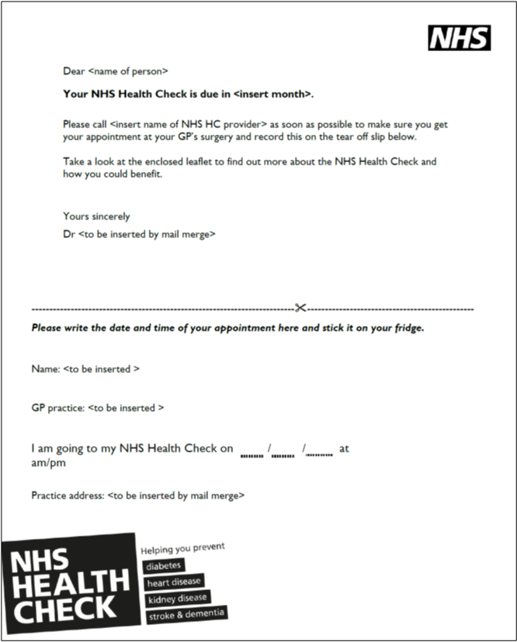

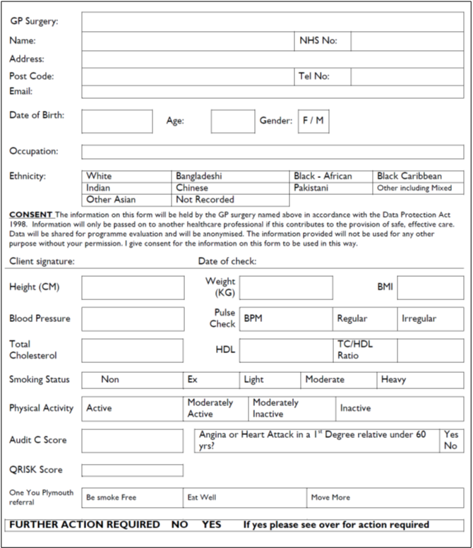
Appendix 2: NHS HC Monitoring Form

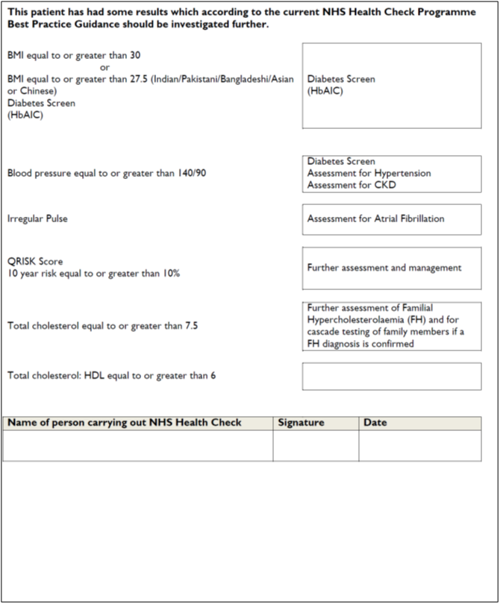

Appendix 3: Useful links

Public Health England publications:
NHS Health Check Programme: Best Practice Guidance
NHS Health Check programme standards: a framework for quality improvement
NHS HC Results card and booklet
www.healthcheck.nhs.uk/commissioners_and_providers/guidance/national_guidance1

Office for Health Improvement and Disparities (OHID training resources
Videos
https://www.healthcheck.nhs.uk/commissioners_and_providers/training/training_videos1/

E Learning
https://www.healthcheck.nhs.uk/commissioners_and_providers/training/elearning_resources1/

Dementia training tool
www.healthcheck.nhs.uk/national_resources/dementia_resources/

NHS Health Check Competence Framework and supporting workbooks
https://www.healthcheck.nhs.uk/commissioners_and_providers/training/competence_framework_supporting_workbooks/

MHRA: Management and use of IVD point of care test devices Dec 2013
www.gov.uk/government/uploads/system/uploads/attachment_data/file/371800/In_vitro_diagnostic_point-of-care_test_devices.pdf

NICE Guidance
Physical activity
www.nice.org.uk/PHI002

Preventing type 2 diabetes:
www.nice.org.uk/PH38

Alcohol IBA in Primary Care.
www.alcohollearningcentre.org.uk/eLearning/IBA

Management and use of IVD point of care test (POCT) devices
Device bulletin December 2013

NHS Health Check patient results card
dan.preece@plymouth.gov.uk

United Kingdom Accreditation Service
www.ukas.com

Appendix 4 Other Local Services

Harbour Centre Plymouth
01752 434343 / 434567
harbourcentre@harbour.org.uk
www.harbour.org.uk
Harbour Drug & Alcohol Services
Hyde Park House, Mutley, Plymouth, Devon PL4 6LF

Hamoaze House Plymouth
01752 566 100
office@hamoazehouse.org.uk
www.hamoazehouse.org.uk
Hamoaze House, Devonport, Plymouth, Devon PL1 4JQ

Livewell Soutwest
01752 268011
Mount Gould Local Care Centre, 200 Mount Gould Road, Plymouth PL4 7PY

One You Plymouth
01752 437177
www.oneyouplymouth.co.uk

